# Instructions for building an irrigation system for vertical greening step by step

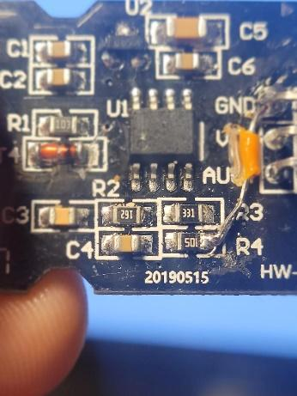

## Step 1: Preparing parts

### Step 1.2. 3D-print all parts for the irrigation system.

* Your outer walls should be at least 3 layers thick. Also use an infill of at least 15%. You can add support structures, but you don’t really need them, because mostly your 3D-printer can bridge every critical area and its not that problematic if some parts of your prints are not perfectly clean. It is very important to use an environment resistant filament like PETG.

### Step 1.3. Check and (hopefully not) repair your moisture sensors

* Check if your capacitive soil moisture sensors are working. There are two ways doing that. First, check if the little dot (picture) is moved to the left and not directly placed under the resistor 4 (R4) if this is the case, like in the picture, your sensor need to get fixed. Your second opportunity is by uploading the following code on your Arduino Nano.

Wire then the sensor like its shown in the picture to the Arduino Nano. 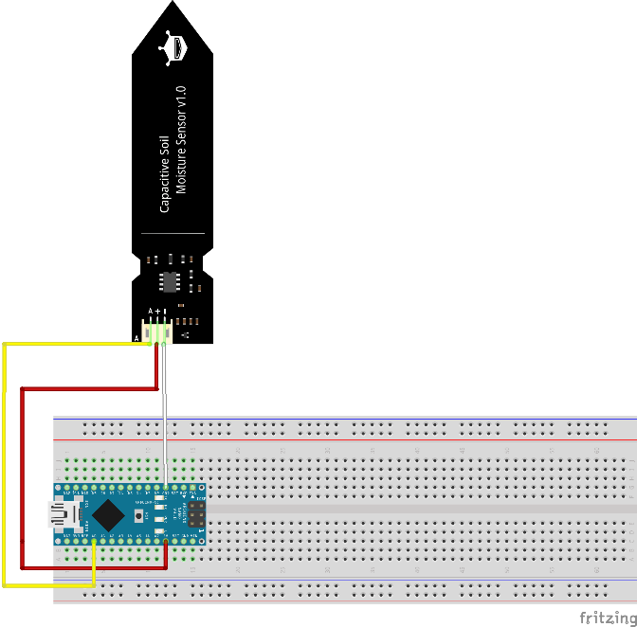

When you touch the sensor now and you do not see a reaction in the values displayed in the serial monitor on your computer, your sensor is broken and needs get fixed.

### Step 1.4. How to fix your capacitive moisture sensor

* Most sensors can be fixed by simply soldering a little wire between resistor 4 (R4) and GND. If this is not working try other methods like its shown in this video: <https://www.youtube.com/watch?v=IGP38bz-K48>

## Step 2. Preparation and flashing of the code

* Download the latest version of Arduino IDE 1.0. from this link (do not download Arduino 2.0. some of the libraries we will use do not work on this IDE):

https://www.arduino.cc/en/software

* Start Arduino IDE and connect the Arduino Nano with a mini-USB cable to your computer. Now go to tools, then on ports and select the port your Arduino Nano is connected to. +
* Now go again to tools, then to processor and select to processor of your board. Usually it is ATmega328T. You can find this information probably on the side you bought the Arduino Nano from.
* Now try uploading a test code and see if uploading the code works. If not type the error message in your browser and follow the instructions to fix the problem.
* Now you need to install two libraries. Libraries are extending your Arduino programming environment. To install a library in your IDE klick on Sketch, then include library, then Manage library. Now you should see a little window with a search bar in which you can type the name of the library you want to include.
* First search for “LiquidCrystal I2C” by Marco Schwartz. Maybe you need to scroll a bit until you find the right library. Klick on install.
* Search now for “DFRobot_DHT11” by Wuxiao and click on install.
* Open the File “irrigationsystem” you downloaded and flash the code in it on the Arduino Nano by pressing this  button in the IDE.
* Disconnect the Arduino from your computer. You will later in the repository learn how to integrate more pumps and soil moisture sensors in the code. Right now you can control two pumps via two relays with two soil moisture sensors.

## Step 3. Assembly of the electronics

* Press the Arduino Nano into the breadboard.

### Step 3.2. Setting up the lcd display

* Wire the LCD display like it is shown in the picture with dupont jumperwires.
* Connect GND from the Arduino Nano to one of the two pin rows on the side of the breadboard
* Connect V5 of the Arduino Nano to the other row.
* Connect the GND from the display to the side row, which is connected to GND at the Arduino.
* Connect VCC from the display to the 5V row on the breadboard.
* Connect then SDA from the display to A4 from the Arduino.
* Connect then SLC from the display to A5 from the Arduino.

### 

### Step 3.3. Connecting the capacitive switch

* Wire the capacitive switch like it is shown in the picture with dupont jumper wires to the Arduino.
* Connect GND from the capacitive switch to the side row, which is connected to GND at the Arduino.
* Connect VCC from the capacitive switch to the 5V row on the breadboard.
* Connect the signal pin to digital pin 6. 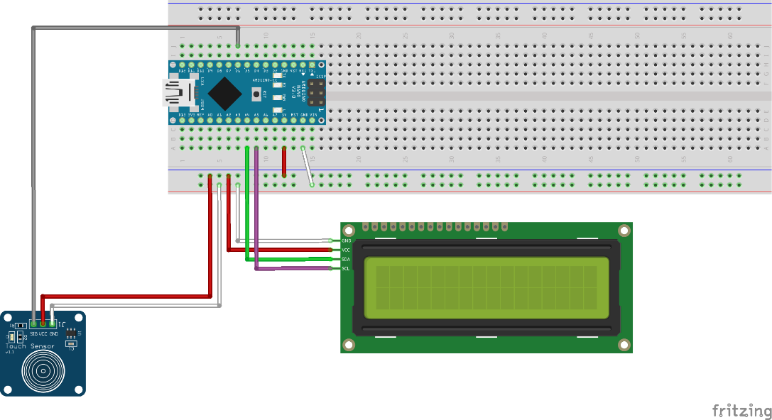
* Connect the Arduino to your computer and touch the capacitive switch. Now you should see the display light up. If not, try turning the potentiometer on the back, until you see characters on the lighted display. If the display turns off, just press the capacitive switch again.

### Step 3.4. Connecting the temperature and humidity sensor

* Wire the DHT 11 like it is shown in the picture with dupont jumperwires to the Arduino.
* GND on the DHT 11 goes to the GND row on the breadboard
* VCC on the DHT 11 goes to the 5V row on the breadboard
* The signal pin on the DHT 11 goes to digital pin 10 on the Arduino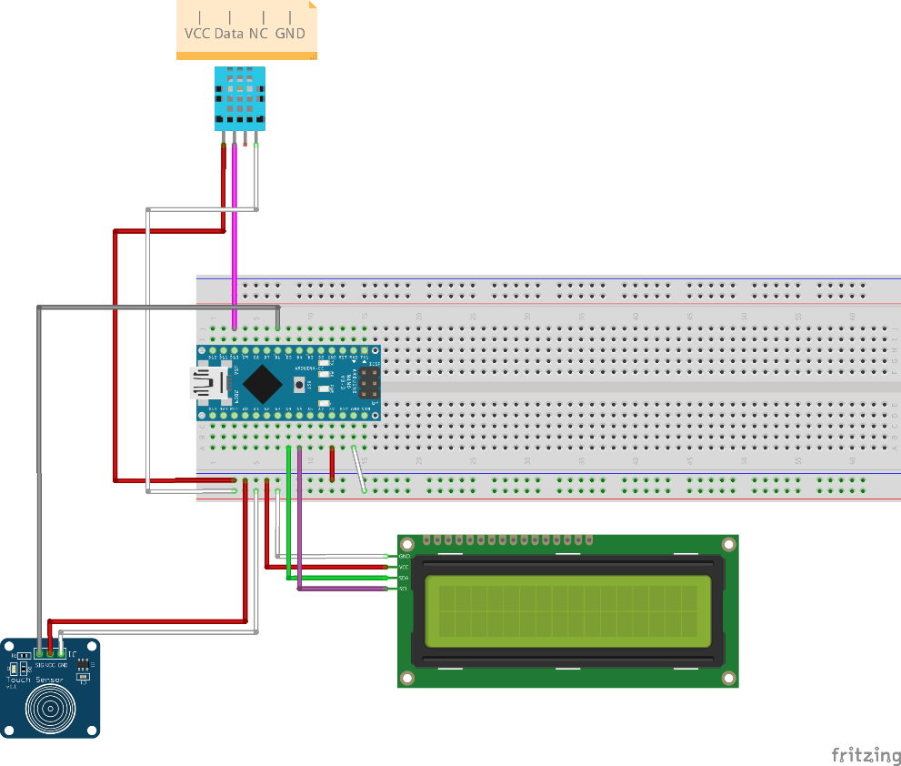
* Connect the Arduino to your computer. Now you should see the temperature and the humidity of your environment displayed on the screen.

### Step 3.5. Connecting the relays and soil moisture sensors

* Wire one of your relays and one of your soil moisture sensors like it is shown in the picture with dupont jumperwires to the Arduino.
* GND of the relay goes to the GND row on the breadboard.
* VCC of the relay goes to the V5 row on the breadboard.
* The input pin of the relay goes to digital pin 2 of the Arduino.
* Connect GND of the soil moisture sensor to the GND row on the breadboard.
* Connect VCC of the sensor to the 5V row.
* Connect the output pin of the sensor to analog pin 3.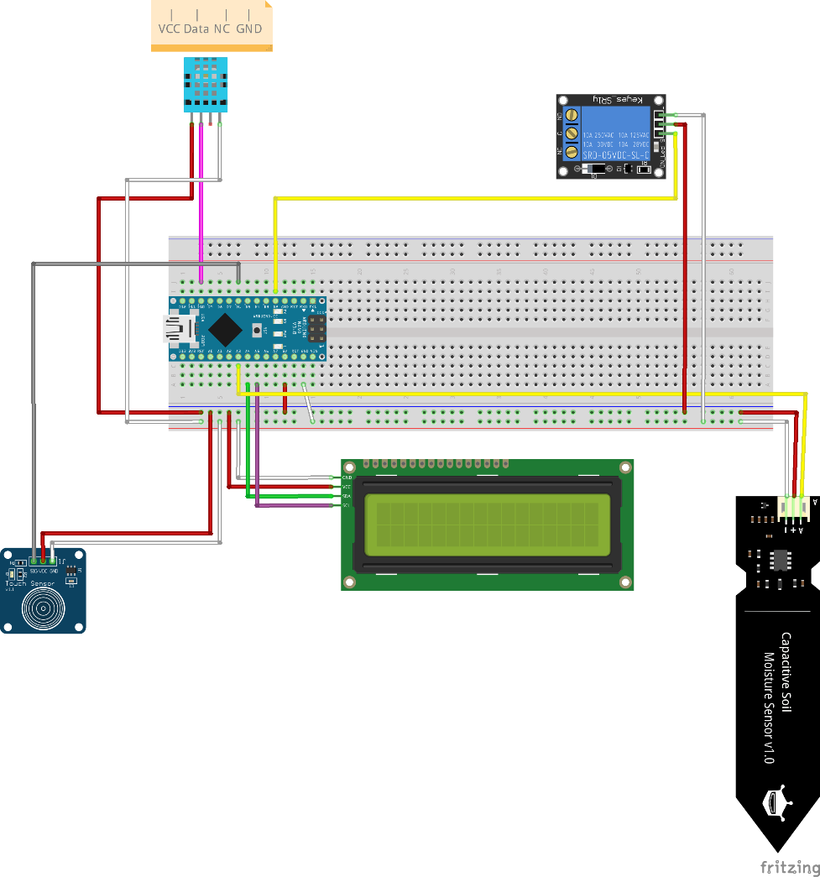
* Connect the Arduino to your computer. When you touch the sensor, you should see the sad smiley behind “plant1” turning into a happy one.
* Connect a second relay and sensor the same way, but this time you connect the input pin from the relay to digital pin 3 on the Arduino and the output pin on the sensor to analog pin 7.
* You can add to every free digital pin a relay, following the same principle you just learned.
* You can add to every free analog pin a soil moisture sensor, following the same principle you just learned.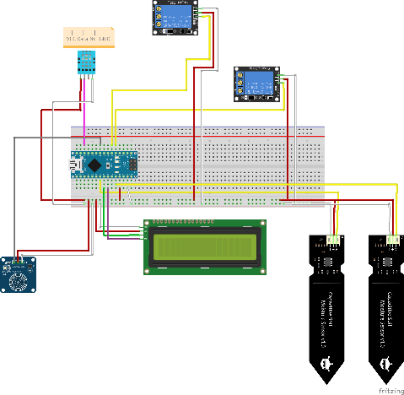
* Now you need to learn how to integrate the added sensors and relays in the code.
* Copy the following code into the irrigation system code. In the code you find a line which looks like this: “//copy in here the code for another relay you want to control with another sensor”. Copy the code under this line.
* Everywhere **X** you see in the code you need to replace by the number of your soil moisture sensor. If you are adding the third sensor, for example, you need to replace every **X** with a 3. Everywhere in the code you see something fad, replace it with the data it needs. That should be self-explaining. 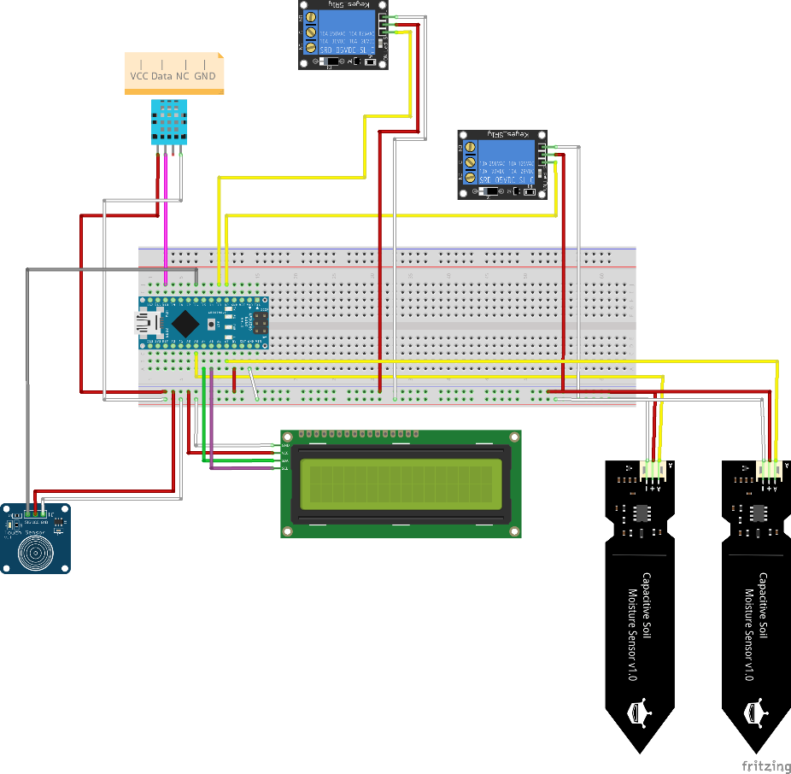
* If you want to control for example three pumps with one sensor, copy each red shaded command directly down one line and change the bold by the digital pin you connected the relay of the pump to.











### Step 3.6. Waterlevel sensor

* To receive data from the tank you will later store the water for your plants in, we need to build our one sensor. Therefore we need two screws with a water-resistant alloy, some wire and a 1K resistor. Strip off the hull on both ends of one cable and solder on one end the screw and on the other end a male dupont plug, isolate it with some heat shrink tubing or insulating tape. Do the same thing for the other cable.
* Now connect one cable to the 5V row and the other one to digital pin 5 on the Arduino. Now connect GND and digital pin 5 with the 1K resistor.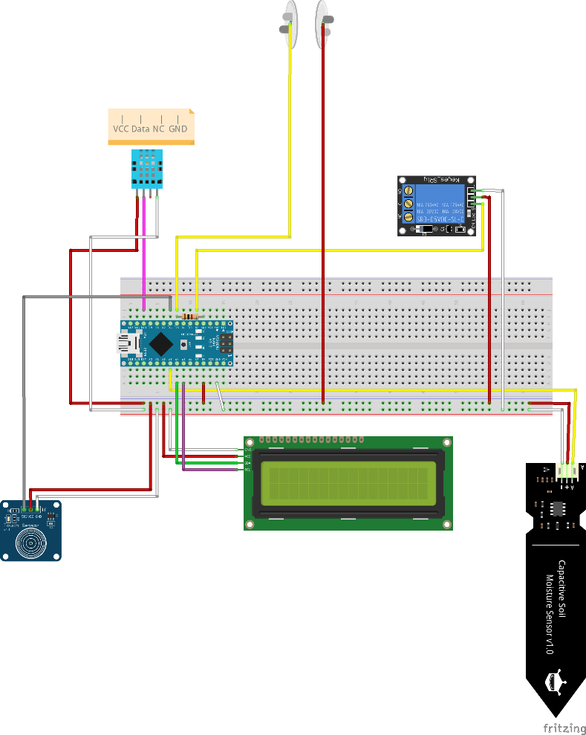
* Connect the Arduino now to your computer and hold the two screws together. You should now hear the relays clicking and if you separate the screws now, you can here them clicking again.
* Congratulations if everything is working. You finished the most complicated part of the repository. If something is not working or your display is bugging. Check all connections if you have a short circuit and if everything is like it is in the repository. Maybe try the unchanged code from the download page and press all plugs again into the breadboard.

## Step 4 building the irrigation system into its housing

* Clean the prints
* Screw the display in place, with four M3x5mm hexagonal bolts, using the wholes on the back of the box.
* Remove the adhesive tape cover from the bottom of the breadboard and stick it in the main housing like it is shown in the picture.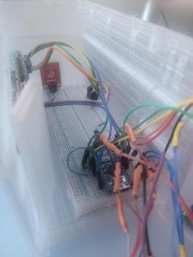
* Screw with two M3x5mm hexagonal bolts the DHT 11 in place. Then glue the capacitive touch switch in the little rectangle, positioned on the right hand side of the display.
* Extend the wires of the sensors by cutting them in half and soldering a one meter jumper wire between every half. If you need the cables to be longer than one meter use longer cables or solder some of the 1 m jumper wires together, isolate everything with some heat shrink tubing or insulating tape. Be aware, that if the cable is too long the signal might have some issues to reach the Arduino.
* Now thread every cable through the plate, like it is shown in the picture.

If you are using a power plug, because you are using the system to water your plants inside, cut off the end of the cable of the power plug and strip the hull from the wire of. Then solder on every wire a male dupont plug and isolate it with some heat shrink tubing or insulating tape. Thread these two cables through the power in port and connect + with VCC and – with GND on the Arduino.

If you are using a solar panel, just wait. We will cover later how you can power the system with a solar panel.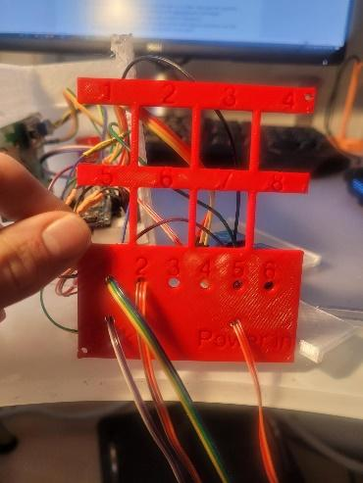

* Now secure every cable with a layer of hot glue, so they can’t separate themselves from the breadboard, the display, the DHT 11, the relays or the capacitive touch switch.
* Slide the plate in the groove. Glue your relays on the shelf boards using some hot glue and press the boards in place, like it is shown in the picture. 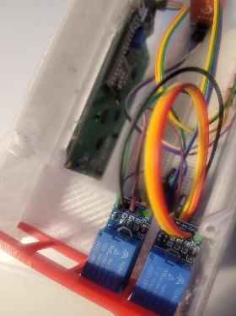
* If you are going to use the system outside, seal every opening with some hot glue. 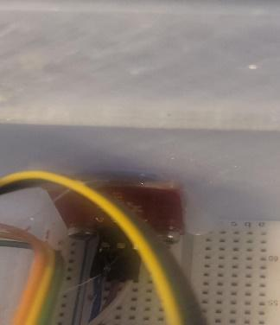

This is how the final system looks like:

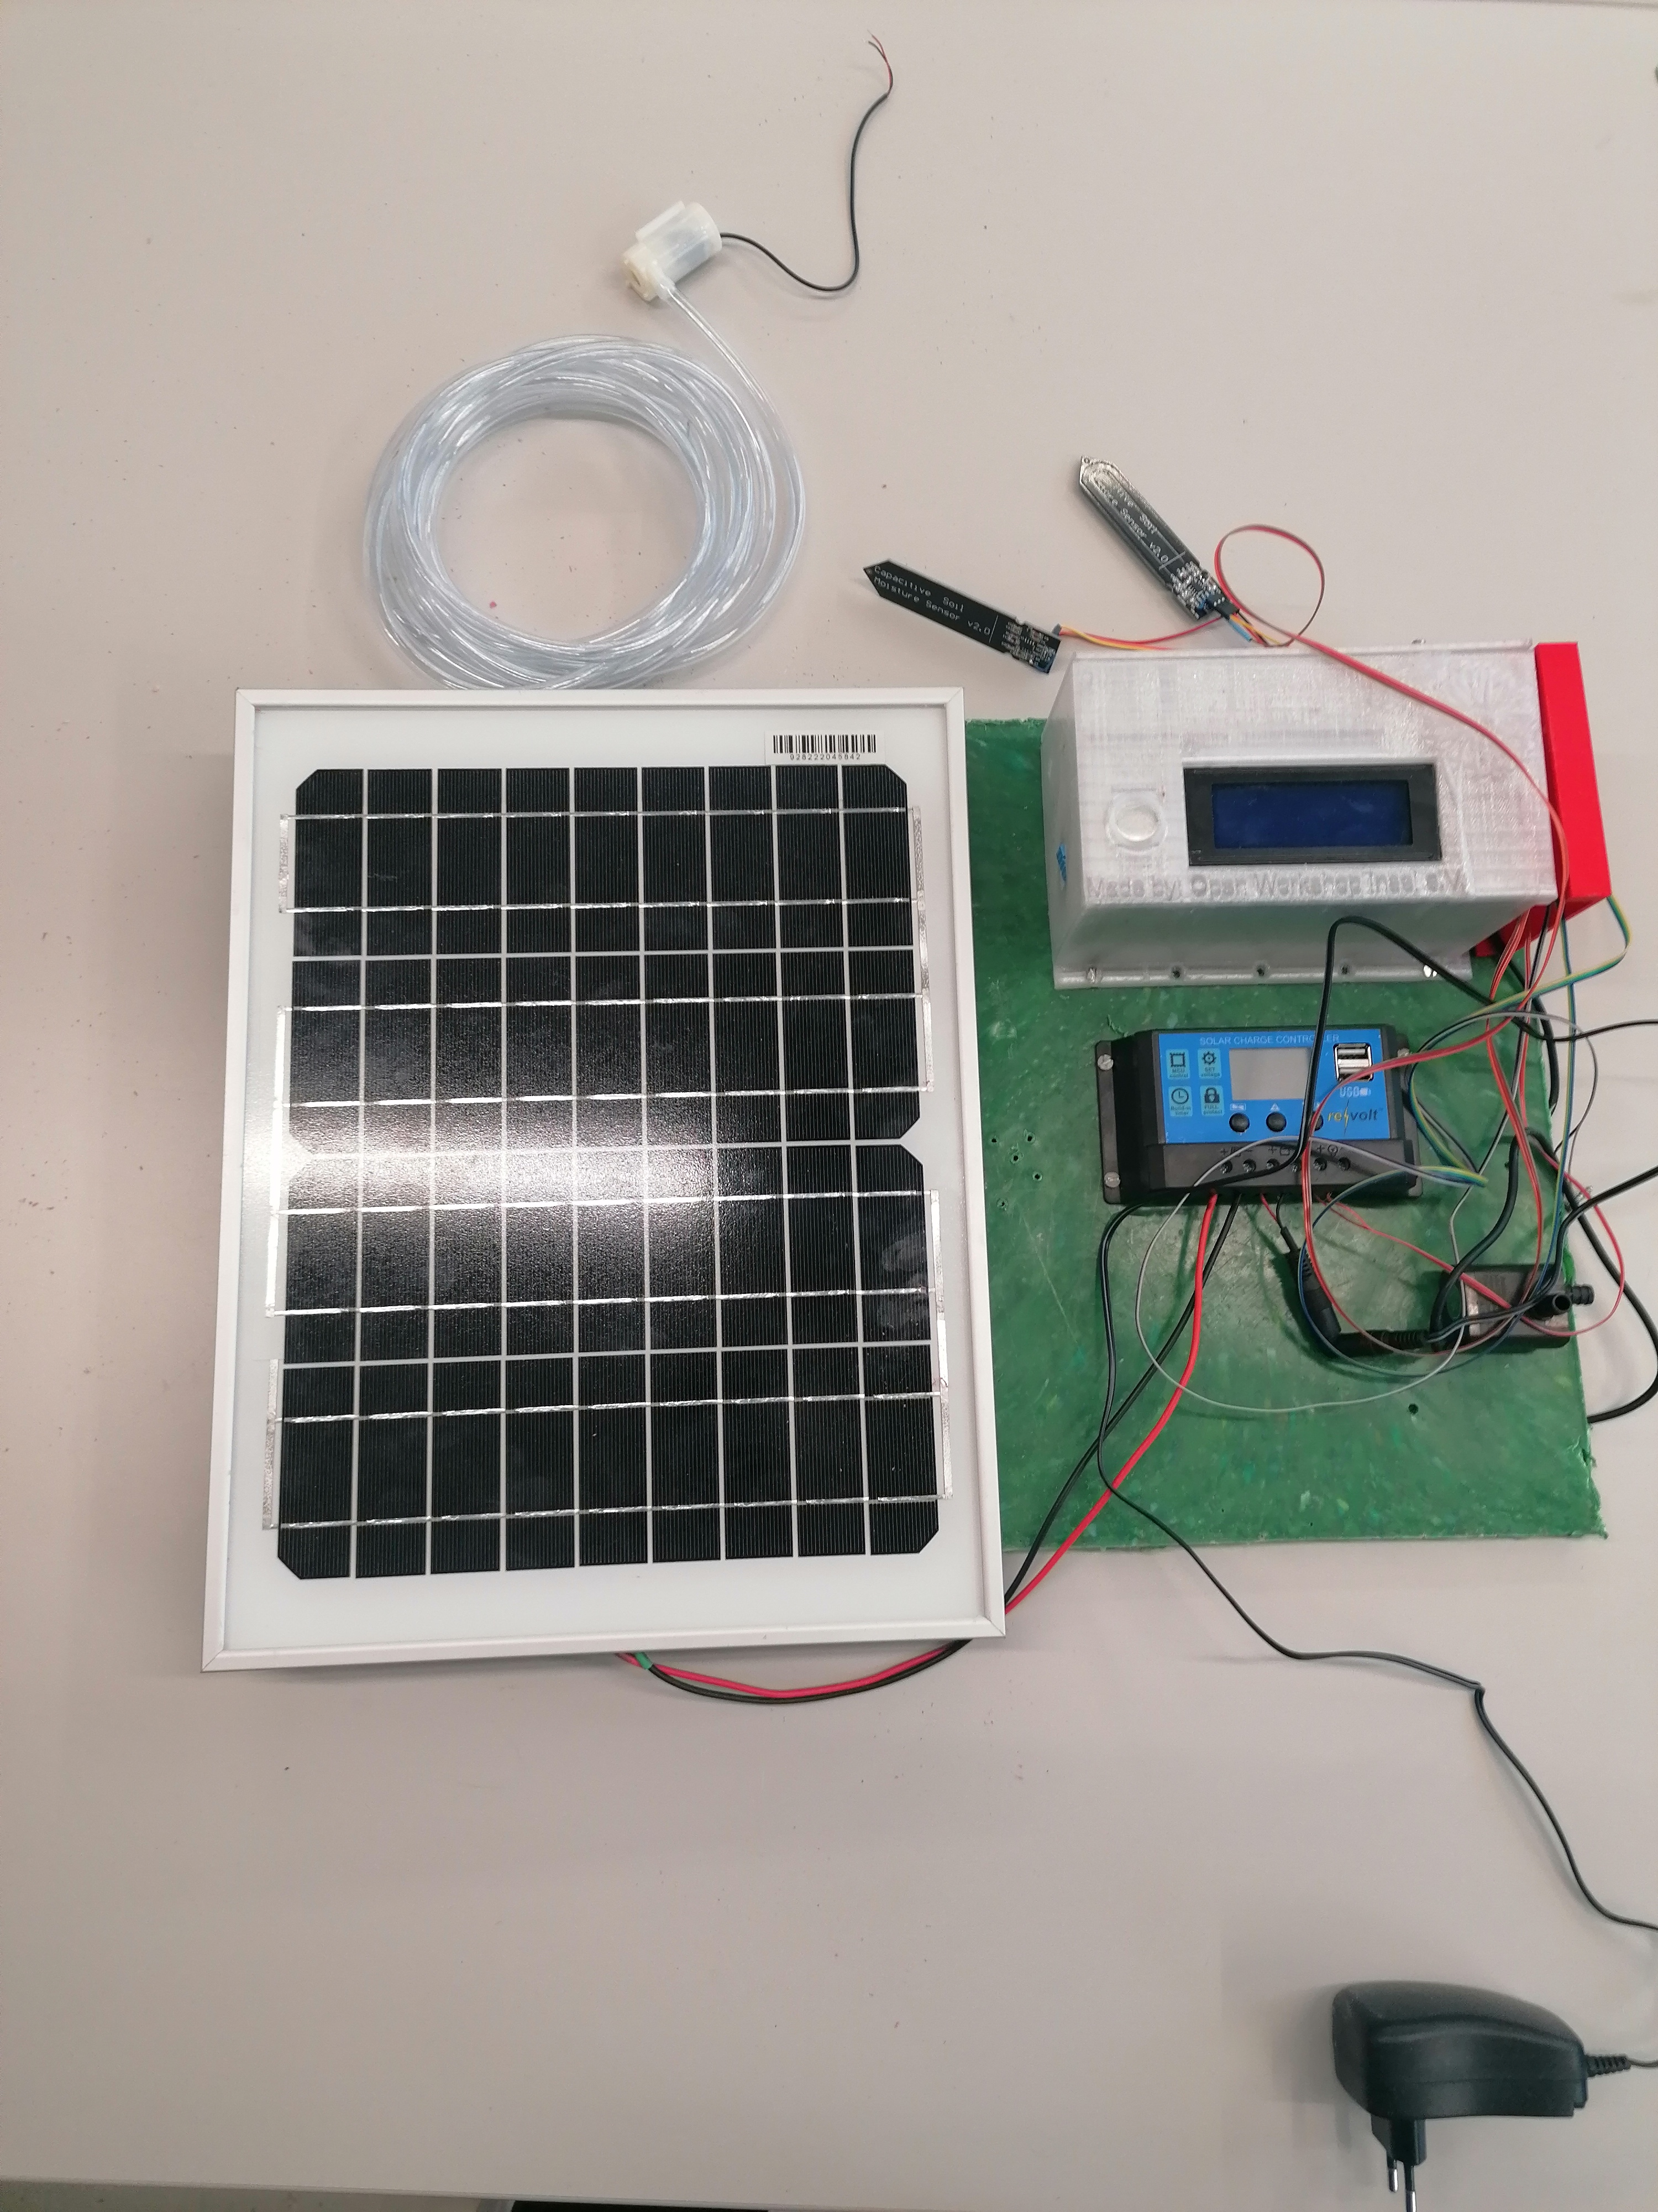

**License**

[Vertikale Pflanzenbehälter für Stabmattenzäune](https://werkstatt.insel-ev.de/vertikalbegruenung) © 2023 by [insel e.V. Offene Recycling-Werkstatt](https://werkstatt.insel-ev.de) is licensed under [Attribution-NonCommercial-ShareAlike 4.0 International](http://creativecommons.org/licenses/by-nc-sa/4.0/?ref=chooser-v1)



This instruction was made by Leven Hennig and will be updated due to the next changes.